How to shut off utilities in an emergency:
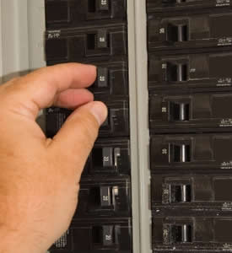
Locate each of these utility control points at home:
- Power (Electricity)
- Gas (natural, propane, or LPG)
- Water
How to turn the Power Off and On at home:
You can turn off or on the power at the circuit electrical panel.
To turn off the power:
- Flip the breaker to “off.”
- Start with the smaller breakers first.
- Flip each breaker one by one.
- Flip the main breaker last.
To turn on the power, repeat steps 1 to 4 by flipping the breaker to “on.”

What to do if you lose power:
- Check your electrical panel for tripped breakers or blown fuses. Reset the breakers by turning them “off” then “on.” Replace any blown fuses.
- Call your utility company and report the outage.
- Turn on an outside light to help the utility crews know when you have power again.
- When the power has been turned back on, turn off major appliances, computers and television to keep the circuits from overloading. Check on your neighbors or people who may not be able to cope without power.
When you are without power for some time:
- Use flashlights or light sticks, instead of candles. Candles can start fires.
- Keep refrigerator and freezer doors closed to keep contents cool. A full freezer will stay cold longer. Fill in empty spaces with milk jugs of water. (it is best to do this before a power outage.)
- If your stove does not work, use a camp stove or barbecue outside. Do not use the camp stove or barbeque indoors.
- If your heater does not work, use your fireplace or woodstove. Do not use kerosene or propane heaters inside without proper ventilation. They create dangerous fumes.
- If you have a generator, be sure to use it correctly. Make sure it ventilates away from your home. Ask a professional for help.
When you are outdoors:
- Stay clear of downed power lines.

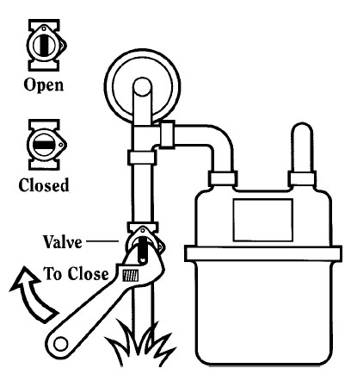
How to turn the Natural Gas off:
- Use an adjustable wrench.
- Tighten the wrench around the shut off valve. The
shut off valve is on the stand pipe that goes into
the gas meter.
- Turn the wrench one quarter turn.
- Once the gas is off, leave it off. Call the gas
company when you are ready for the gas to be
turned back on.
When to turn the Natural Gas off at the meter:
- Shut off your gas only if you smell gas or hear a
hissing noise or have some reason to believe there
is a problem or break in the gas line.
- Once the gas is off, leave it off. Call the gas
company when you are ready for the gas to be
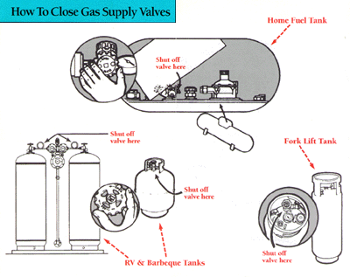
turned back on.
How to turn the Propane Gas or LPG off at the meter:
- Open the top of the tank.
- Find either a regular turn knob
or a quarter turn valve.
- For turn knobs, turn the knob to
your right to shut off the flow of
propane into your house.
- For quarter turn valves, see
instructions for natural gas.
- Once the gas is off, leave it off.
Call the gas company when you
are ready for the gas to be
turned back on.
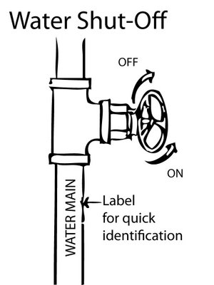
How to turn Off or On the main Water supply to your home:
- Find the main water valve.
- To turn off the water, turn the valve to your right.
- To turn on the water, turn the valve to your left.

